***PBL PROJECT***

**NAME: MALAY JOGI**

**ERP: 20SOECE11020**

**ROLL NO: 18**

**CLASS: 3CEA**

**RKU**

***PROBLEM***

**1)** HOW TO ORGANIZE EACH FILE IN A SPECIFIC FOLDER WITH THE SAME EXTENSION? (AND THE FOLDER SHOULD BE CREATED DYNAMICALLY BASED ON EXTENSION, ALSO ALL THE FILES WILL BE PLACED IN A RESPECTIVE FOLDER)

**EXAMPLE:-**

MALAY_JOGI.PDF 🡪 THIS FILE WILL GO IN PDF FOLDER

Mj.png-🡪 THIS FILE WILL GO IN PNG FOLDER

3CEA.JPEG🡪THIS FILE WILL GO IN JPEG FOLDER

PBL.PY 🡪 THIS FILE WILL GO IN PY FOLDER

***WRITE A CODE IN PYTHON, DEVELOP ALGORITHM AND A FLOW CHART FOR THE SAME……***

HINT: USE OS AND SHUTIL MODULE

***SOLUTION***

***FLOWCHART***

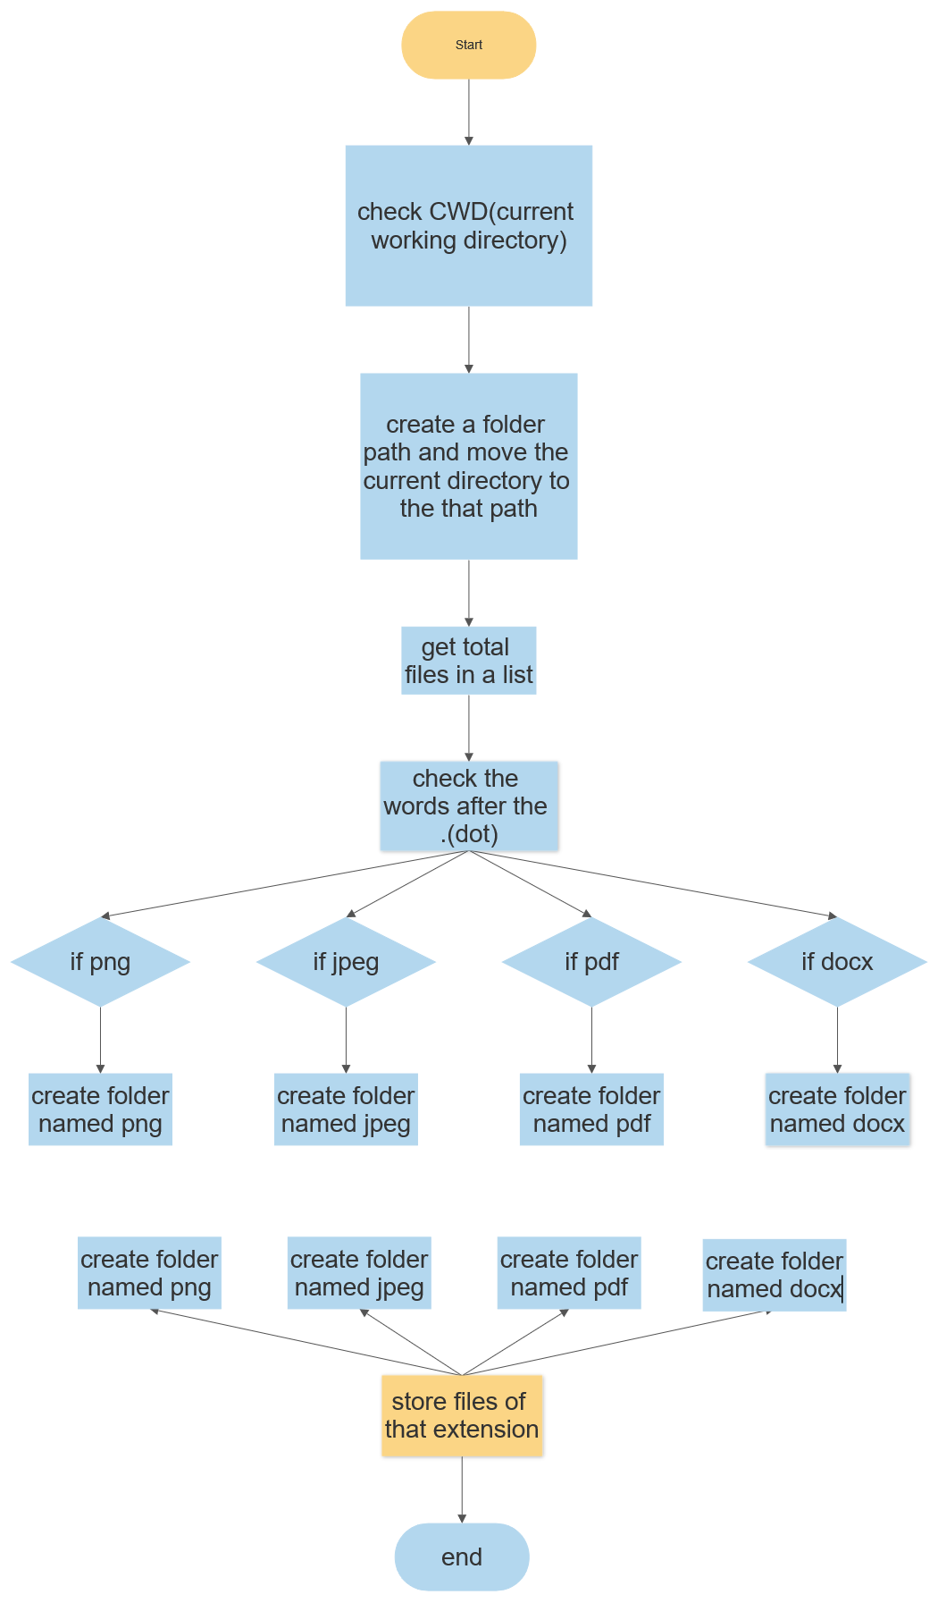

***ALGORITHM***

Step-1: import os and shutil module

Step-2: find the folder path and create a variable and store it

Step-3: check current working directory with help of os module

Step-4: change the working directory to folder path with help of os module

Step-5: get total no. of files in a list with the help of os module

Step-6: split and get words after the dot(.) and store it in list

Step-7: create a folder with os module, if exist then delete the folder and again create it

Step-8: create sub-folders with the name of extension

Step-9: move the files of that extension

***OS module***

the os module interacts with the operating system, it is in-built module in python

The functions we are going to use of os modules are:

1) os.cwd

2) os.chdir

3) os.mkdir

4) os.listdir

--5) os.remove

--6)os.rmdir

7)os.environ

***Shutil module***

It is similar to os module but it deals with manipulation of file system and os module deals with collection of files

Manipulation – copy,remove,cut etc..

Functions which we are going to use of shutil-

1)shutil.rmtree

2)shutil.copy